SKILLS SNAKES & LADDERS

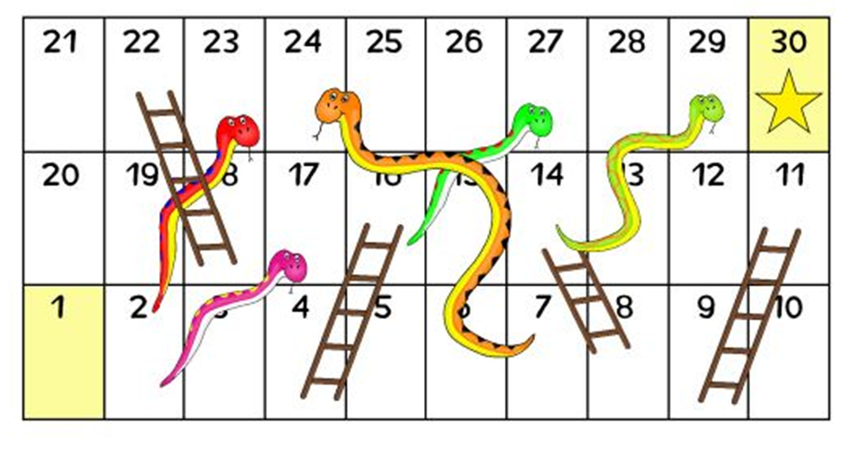
KILL
NUMBER  CHALLENGE | EASY CHALLENGE | MEDIUM CHALLENGE | HARD CHALLLENGE | SUPERSTAR CHALLENGE
1 – GET STARTED
2 - PLANK | 45 secs | 90 sec | 2 mins | 3 mins
3 - PRESS UPS | 10 | 20 | 30 | 50+
4 - BURPEES | 10 | 20 | 30 | 40+
5 – STEP UPS | 30 | 45 | 60 | 75+
6 – PARTNER SELECTS CHALLENGE
7 – BICEP CURLS | 10 | 15 | 25 | 35+
8 – EXERCISE OF YOUR CHOICE
9 – LIFT IT | 15 items | 20 items | 25 items | 35+ items
10 - CRUNCHIES | 15 | 25 | 30 | 40+
11 – SIT UPS | 15 | 25 | 30 | 40+
12 – BOX JUMPS | 10 | 15 | 20 | 25+
13 – PRESS UPS | 10 | 20 | 30 | 50+
14 – PARTNER SELECTS CHALLENGE
15 – PLANK - 1 ARM | 45 secs | 90 sec | 2 mins | 3 mins
16 – YOUR CHOICE
17 – STEP UPS | 30 | 45 | 60 | 75+
18 – BICEP CURLS | 10 | 15 | 25 | 35+
19 - BURPEES | 10 | 20 | 30 | 40+
20 – LIFT IT | 15 items | 20 items | 25 items | 35+ items
21 - CRUNCHIES | 15 | 25 | 30 | 40+
22 – SIT UPS | 15 | 25 | 30 | 40+

NUMBER  CHALLENGE | EASY CHALLENGE | MEDIUM CHALLENGE | HARD CHALLLENGE | SUPERSTAR CHALLENGE
1 – GET STARTED
2 – Keepy ups | 15 | 25 | 35 | 50+
3 – Throw & Catch | 15 | 30 | 50 | 60+
4 – Dribble | 5 | 8 | 10 | 12+
5 – Juggle with 2 balls | 15 secs | 30 secs | 45 secs | 1 min +
6 – PRACTICE YOUR FAVOURITE SKILL |  |  |  | AIM HIGH
7 – Speed bounce | 20 | 40 | 60 | 70+
8 – Weaving run | 5 | 8 | 10 | 12+
9 – Hit the Target | 5 | 10 | 15 | 20+
10 – Throw & Catch | 15 | 30 | 50 | 60+
11 – Sprint | 4 | 6 | 8 | 10
12 – Pick up Run | 4 | 5 | 6 | 8
13 – Keepy Ups | 15 | 25 | 35 | 50+
14 – PRACTICE LEAST SUCCESSFUL SKILL |  |  |  | IMPROVE YOUR SCORE
15 – Sprint | 4 | 6 | 8 | 10
16 – Hit the Target | 5 | 10 | 15 | 20+
17 – Juggle with 2/3 balls | 15 secs | 30 secs | 45 secs | 1 min +
18 – PRACTICE LEAST SUCCESSFUL SKILL |  |  |  | AIM HIGH
19 – Pick up Run | 4 | 5 | 6 | 8
20 – Speed bounce | 20 | 40 | 60 | 70+
21 – Throw & Catch | 15 | 30 | 50 | 60+
22 – Hit the Target | 5 | 10 | 15 | 20+
23 – Keepy Ups | 15 | 25 | 35 | 50+
24 – PRACTICE FAVOURITE SKILL – AIM HIGH |  |  |  | IMPROVE YOUR SCORE
25 – Sprint | 4 | 6 | 8 | 10
26 – Weaving run | 5 | 8 | 10 | 12+
27 – Dribble | 5 | 8 | 10 | 12+
28 – Speed bounce | 20 | 40 | 60 | 70+
29 – Your choice of skill |  |  |  | ENJOY
30 – CHALLENGE COMPLETED

THROW & CATCH AGAINST A WALL
OR TO A PARTNER IN 1 MIN
WEAVING RUN IN 1 MIN USE ANY SUITABLE OBJECTS TO RUN ROUND
KEEPY UPS IN 1 MIN
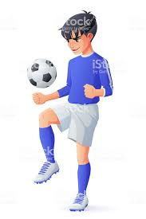
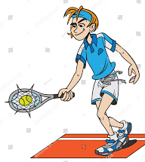
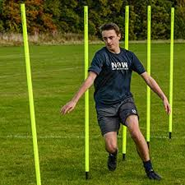
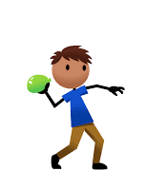

SPEED BOUNCE -2 FOOTED JUMPS OVER OBJECT 15 CMS HIGH

JUGGLING
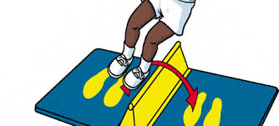
DRIBBLE AROUND CONES 10 STRIDES APART
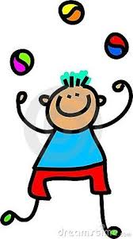

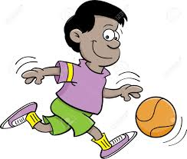
PICK UP OBJECT RUN TO OTHER END PUT IN TARGET PICK UP ANOTHER OBJECT RUN BACK & REPEAT FOR 1 MIN
SPRINT BETWEEN 2 CONES 10 STRIDES APART
TOUCH CONE EACH TIME

HIT THE TARGET
